MINISTRY OF EDUCATION AND TRAINING



**Capstone Project Document**

**Hotel Website**

**Project Code: HOWE**

|  |  |  |
| --- | --- | --- |
| Project Team | | |
| Group members | Nguyen Viet Hung | SE03577 |
| Vu Tran Hoang | SE03931 |
| Dang Cong Son | SE03564 |
| Dang Duc Manh | SE03539 |
| Tran Ba Quyen | SE02724 |
| Supervisor | **Mr.Phan Truong Lam** | |
| Capstone Project Code | **HOWE** | |

Ha Noi May 8th, 2017

**Definition and acronyms**

|  |  |  |
| --- | --- | --- |
| Acronym | Definition | Note |
| HOWE | Hotel Website | Project’s name |
| SRS | Software Requirement Specifications |  |
| CI | Configuration Item |  |
| CM | Configuration Management |  |
| Admin | Administrator |  |
| Member | Employer and Job Seeker |  |
| PM | Project Manager |  |
| PTL | Project Technical Leader |  |
| CRC | Class-Responsibility-Collaborators |  |
| AT | Acceptance Test |  |
| IT | Integration Test |  |
| KLOC | 1000 lines of code |  |
| PM | Project Manager |  |
| PTL | Project Technical Leader |  |
| PT/TT | Program Test/ Total Test |  |
| QA | Quality Assurance |  |
| UT | Unit Test |  |
| PC | Personal Computer |  |
| UI | User Interface |  |

# INTRODUCTIONはじめに

## PURPOSE　目的

This chapter provides an overview of Hotel Website, it includes background information and literature review of existing system.

## PROJECT INFORMATION　プロジェクトの情報

|  |  |
| --- | --- |
| Project name: | Hotel Website |
| Project code: | HOWE |
| Project type: | Website |
| Project category: | New development |
| Business type: | Business |
| Project manager: | Nguyen Viet Hung |
| Timeline: | May 8th,2017 to August 26th,2017 |

Table 1.2 – Project Information

## PROJECT MEMBERS プロジェクトメンバー

* Supervisor:

|  |  |  |
| --- | --- | --- |
| Full name | E-mail | Title |
| Phan Truong Lam | [Lampt2@fe.edu.vn](mailto:Lampt2@fe.edu.vn) | Lecturer |

* Team members:

|  |  |  |  |  |
| --- | --- | --- | --- | --- |
| Full name | Roll number | E-mail | Phone | Position |
| Nguyen Viet Hung | SE03577 | [hungnvse03577@fpt.edu.vn](mailto:hungnvse03577@fpt.edu.vn) | 01648172064 | Leader |
| Vu Tran Hoang | SE03931 | [hoangvtse03931@fpt.edu.vn](mailto:hoangvtse03931@fpt.edu.vn) | 096.296.2174 | Member |
| Dang Cong Son | SE03564 | [sondcse03564@fpt.edu.vn](mailto:sondcse03564@fpt.edu.vn) | 0129 639 6358 | Member |
| Dang Duc Manh | SE03539 | [manhddse03539@fpt.edu.vn](mailto:manhddse03539@fpt.edu.vn) | 01662451994 | Member |
| Tran Ba Quyen | SE02724 | [quyentbse02724@fpt.edu.vn](mailto:quyentbse02724@fpt.edu.vn) | 01636969459 | Member |

## OUR PROPOSAL 提案

### Problem 問題

Vietnam, with 8 world heritage sites, 11 intangible cultural heritages, traditional customs maintaining the national identity, and thousands of resorts and tourist destinations has been attracting millions of local and foreign tourists every year. The higher the number of tourists is, the greater the demand for accommodation and hotel services increases, resulting in the establishment of more hotels.

In fact, a hotel in Halong just has ordered project team a website aimed at promoting the image and facilitating online hotel reservations base on an existing website. However, after discussion, the team founded that the current system does not meet the requirements of that hotel’s business. In addition, the booking process of not only this website but also many similar one are too complex that caused many obstacles to the customers.

### Solution 解法

Together with the customer solve the problem to meet the condition and requirements of the hotel. Simplify but maintain the effectiveness of the process of looking for accommodation and booking.

### Idea アイディア

Design a website meeting all requirements, including heavily promoting the hotel’s image, offering customers with a time-saving and efficient booking service, and providing favorable conditions for the hotel management in the near future.

## LITERATURE REVIEW OF EXISTING WEBSITES

In this section we will describe some three-stars hotel’s website respectively corresponding such as:

Kim Lien Hotel: <http://www.kimlientourism.com.vn/>

Hilton hotel: <http://www3.hilton.com/en/index.html>

### Kim Lien Hotel キムリエンホテル

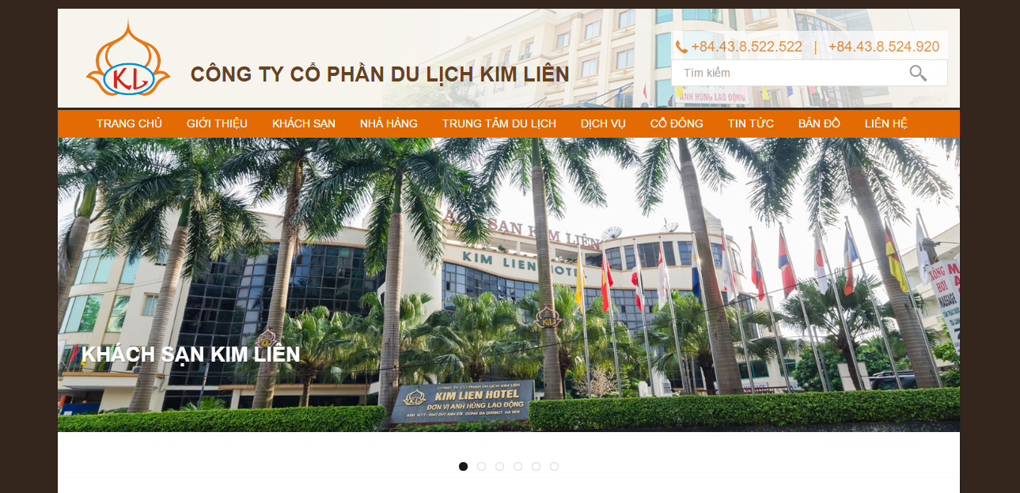

User interface design simple, friendly. Provide quite enough information about the hotel for guests

* “GIỚI THIỆU”: hotel profiles
* “KHÁCH SẠN”: information on facilities, rooms of the hotel, price
* “NHÀ HÀNG”, “TRUNG TÂM DU LỊCH”, “DỊCH VỤ”
* “CỔ ĐÔNG”: information on the operating apparatus, hotel management activities
* “TIN TỨC”, “BẢN ĐỒ”, “LIÊN HỆ”

However, the online booking function of hotel has not really optimized, many inadequacies and the implementation process is quite complex. Searching room information is not checked before execution, guests can not see basic information about rooms that can be booked.

### Hilton Hotel　ヒルトンホテル

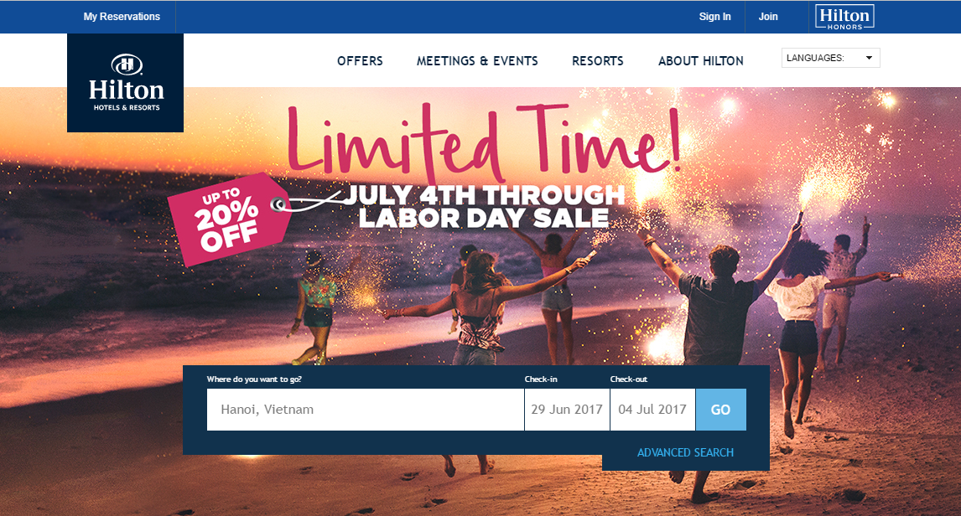

Website of Hilton hotel is designed simple, beautiful. That also provide basically information such as:

* Offers: providing for guests with special service packages
* Meetings & events: information for conferences, events featured in the hotel
* Resorts: information for resorts of hotel
* About Hilton: hotel profiles
* My reservation: search, change information of myself reservation

The online booking function of hotel is quite complete compared to Kim Lien hotel, but like Kim Lien, the online booking process is still complicated through many steps to complete the reservation

### Comparison

This section will list some of the comparison criteria for HOWE with Kim Lien and Hilton hotel, which are built on the guest’s perspective of the system

|  |  |  |  |
| --- | --- | --- | --- |
| Tiêu chí đánh giá | HOWE | Kim Lien Hotel | Hilton Hotel |
| Ease of use of the website |  |  |  |
| Simple design of the website |  |  |  |
| The simplicity of the online booking room function |  |  |  |
| Provided information on the website |  |  |  |
| Multi languages |  |  |  |
| Online payment |  |  |  |

## PRODUCT　商品

Following the research on hotel’s business, the most important and necessary functions have been proposed. The operations will be simple and easy to understand, the interface will be neatly designed and friendly with users.

Basic Functions:

Guest

* Booking room
* Search room
* Sent feedback, Q&A
* View hotel page
* Cancel booking room

Receptionist

* View hotel page
* Change password
* Booking Room Management
* Check In
* Check Out
* Create bill

Manager

* Service management
* Page management
* Edit room’s detail
* Account management

Accounting

* Handover finance
* Search bill
* Monthly revenue report

## BENEFIT FROM PROJECT プロジェクトからベネフィット

### For our group グループのために

From this project, after working together to develop this product, we will get some benefits:

* Have more experience on developing software product, project management like how to create the plan for project, estimate resources for it and manage time, process, members and risk.
* Have knowledge about HTML, PHP, Laravel, Bootstap, Jquery, AngolaJS, etc and have a chance to apply those technologies on our project.
* Improve relationship between team members, know how to communicate with each other and make teamwork more effective.

### For user ユーザーのために

* Provide a completely website for customer’s hotel.
* Guests can easily book for room and hotel’s manager can easily manages booking information and guests.
* A website will be useful for hotel in advertising and attracting guests.

# SOFTWARE PROJECT MANAGEMENT　ソフトウェアプロジェクト管理

## SOFTWARE DEVELOPMENT PROCESS　ソフトウェア開発のプロセス

Dưới đây là mô hình xoắn ốc về quy trình phát triển phần mềm được áp dụng đối với HOWE

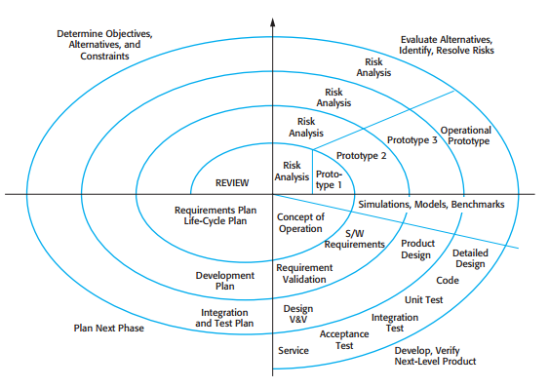

Figure 2.1 – Boehm’s spiral model of software process

Trên đây là mô hình mà HOWE sử dụng để phát triển hệ thống. trên thực tế đã có rất nhiều mô hình phát triển khác được biết đến như waterfall, agile hay incremental, v.v.. các mô hình trên đều được sử dụng rộng rãi và khá phổ biến trong các doanh nghiệp phát triển phần mềm chuyên nghiệp. tuy nhiên với HOWE lại lựa chọn spiral là vì các nguyên nhân sau:

Thứ nhất ở spiral model hội tụ được các tính năng tốt và khắc phục các hạn chế từ các model khác. Chẳng hạn, khi so sánh với waterfall thì spiral vẫn đảm bảo được các bước quan trọng trong quy trình phát triển phần mềm mà waterfall cũng có như phân tích yêu cầu, thiết kế, code, test và bàn giao sản phẩm. tuy nhiên với waterfall, mỗi giai đoạn phải được thực hiển theo các bước nghiêm ngặt, giai đoạn tiếp theo sẽ không được thực hiện khi giai đoạn trước chưa hoàn thành, chính vì vậy mỗi giai đoạn yêu cầu nhân lực dày dặn kinh nghiệm và đương nhiên rủi ro của mô hình này sẽ rất nghiêm trọng.

Thứ hai, spiral model is not a sequence of activities with some backtracking from one activity to another, mỗi vòng lặp là 1 giai đoạn của quá trình phát triển chẳng hạn như tính khả thi của hệ thống, xác định yêu cầu hay thiết kế hệ thống. spiral giúp cho việc quản lý các rủi ro của dự án trở nên dễ dàng hơn so với các mô hình khác, linh hoạt hơn với những thay đổi trong quá trình phát triển dự án, đặc biệt khi mà nhóm phát triển HOWE đều chưa có nhiều kinh nghiệm trong phát triển phần mềm.

## PROJECT ORGANIZATION プロジェクト組織

### Organizational Structure 組織構造

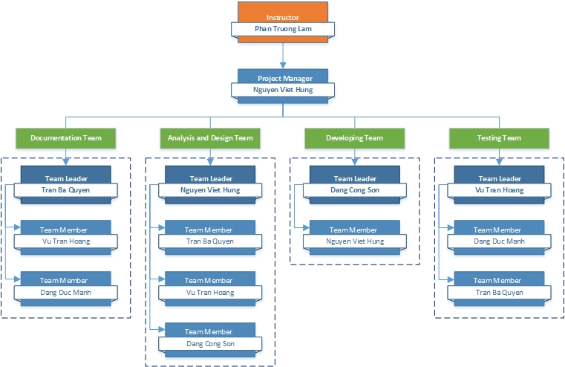

Figure 2.2.1 – Organizational structure chart

### Project Team プロジェクトチーム

|  |  |  |  |  |  |
| --- | --- | --- | --- | --- | --- |
| Role | Responsibility | Full name | % Effort | Start date | End date |
| Instructor | - Provide templates & tools  - Review deliverables  - Review project status  - Resolve escalated issues  - Consultant | Phan Trường Lâm | 10% | 8th May, 2017 | 26th August, 2017 |
| PM | - Planning and defining scope  - Developing schedule  - Reviewing and tracking document  - Assign individual responsibility  - Assign task to team members | Nguyễn Việt Hưng | 100% | 8th May, 2017 | 26th August, 2017 |
| Analysis and Design Team | | | | | |
| Team Leader | - Reviewing and tracking design  - Identify main UI  - Draw prototype, architecture design  - Design Database | Nguyễn Việt Hưng | 100% |  |  |
| Team member #1 | - Draw prototype, architecture design | Trần Bá Quyền | 100% |  |  |
| Team member #2 | - Design database  - Design screen | Vũ Trần Hoàng | 100% |  |  |
| Team member #3 | - Design database  - Design screen | Đặng Công Sơn | 100% |  |  |
| Documentation Team | | | | | |
| Team Leader | - Reviewing and tracking requirement | Trần Bá Quyền | 100% |  |  |
| Team member #1 | - Create SRS Document  - Create Final Report | Vũ Trần Hoàng | 100% |  |  |
| Team member #2 | - Create SRS Document  - Create Final Report | Đặng Đức Mạnh | 100% |  |  |
| Development Team | | | | | |
| PTL | - Developing  - Solve issue of project | Đặng Công Sơn | 100% |  |  |
| Developer #1 | - Developing | Nguyễn Việt Hưng | 100% |  |  |
| QA and Testing Team | | | | | |
| Test Leader | - Responsible for test excution | Vũ Trần Hoàng | 100% |  |  |
| Tester #1 | - Testing | Trần Bá Quyền | 100% |  |  |
| Tester #2 | - Testing | Đặng Đức Mạnh | 100% |  |  |

Table 2.2.2 – Project Team

## PROJECT SCHEDULE　プロジェクトスケージュール

## Meeting minutes　議事録

### Meeting minute 1

|  |  |  |  |
| --- | --- | --- | --- |
| Meeting Minutes 1　議事録１ | | | |
| Subject(議題) |  | **Date(日付)** |  |
| Conductor(指導者) |  | **Time(時間)** |  |
| Location(場所) |  | **Secretary(秘書)** |  |
| Attendees(出席) |  | | |
| Absent(欠席) |  | | |

|  |  |  |
| --- | --- | --- |
| Discussed Point　相談の議題 | | |
| *No.* | ***Topic(テーマ)*** | ***Contents(内容)*** |
|  |  |  |
|  |  |  |
|  |  |  |
|  |  |  |
|  |  |  |
|  |  |  |

|  |  |  |  |  |
| --- | --- | --- | --- | --- |
| Action Plan　プラン実行 | | | | |
| ***No.*** | ***Action Item(s)***  ***アクションアイテム*** | ***Owner***  ***担当者*** | ***deadline***  ***締切*** | ***status***  ***状態*** |
|  |  |  |  |  |
|  |  |  |  |  |
|  |  |  |  |  |
|  |  |  |  |  |
|  |  |  |  |  |

## PROJECT MILLSTONES　プロジェクトマイルストーン

|  |  |  |  |
| --- | --- | --- | --- |
| No | Milestone | Completion Date | Verification |
| 1 | Project Start |  | Instructor approval |
| 2 | Submit report 1 |  | Instructor approval |
| 3 | Submit report 2 |  | Instructor approval |
| 4 | Submit report 3 |  | Instructor approval |
| 5 | Submit report 4 |  | Instructor approval |
| 6 | Submit report 5 |  | Instructor approval |
| 7 | Submit report 6 |  | Instructor approval |
| 9 | Defend project |  | Instructor approval |

## PROJECT DELIVERABLES　プロジェクト成果物

|  |  |  |  |  |
| --- | --- | --- | --- | --- |
| **No** | **Deliverable** | **Committed Delivery date** | **Description of Deliverable** | **Delivery media** |
| 1 | Capstone project register |  |  | Hard copy |
| **Iteration 1** | | | | |
| 2 | Software Requirement Specifications - SRS |  | Document | Commit to Github |
| 3 | Q&A Management |  | Document | Commit to Github |
| 4 | User requirements |  | Document | Commit to Github |
| 5 | Project plan |  | Document | Commit to Github |
| 6 | Progress report 1 |  | Document | Commit to Github |
| 7 | Architecture design |  | Document | Commit to Github |
| 8 | User interface design |  | Document | Commit to Github |
| 9 | Progress report 2 |  | Document | Commit to Github |
| 10 | Database design |  | Document | Commit to Github |
| 11 | Test plan |  | Document | Commit to Github |
| 12 | Test case |  | Document | Commit to Github |
| 13 | Progress report 3 |  | Document | Commit to Github |
| 14 | Progress report 4 |  | Document | Commit to Github |
| 15 | Test case - execute |  | Document | Commit to Github |
| 16 | Test report |  | Document | Commit to Github |
| 17 | Progress report 5 |  | Document | Commit to Github |
| **Iteration 2** | | | | |
| 18 | User manual |  | Document | Commit to Github |
| 19 | Progress report 6 |  | Document | Commit to Github |
| 20 | Final report |  | Document | Hard copy |

## RESOURCES　リソース

### Human resource 人的リソース

* Team members
* Supervisor

### Non-human resource 機器やツール

* Equipment: Desktop, Laptop
* Building: Alpha & Beta Building of FPT University Hoalac Campus

## RISK MANAGEMENT　リスク管理

|  |  |  |  |  |  |  |
| --- | --- | --- | --- | --- | --- | --- |
| No. | Name | Root Cause | Probability | Avoidance plan | Contingency plan | Impact |
| 1 | Project team don’t meet the deadline on time. | Members lack of responsibility  Lack of management. | Medium | Make rules and penalties for member who didn’t meet the deadline. | Working overtime to complete tasks on time. | High |
| 2 | Requirement changed while project is being processed. | SRS is not provide all information about user requirement such as: lack of customer’s requirement, misunderstand customer’s requirement. | High | SRS should be reviewed carefully by PM and Supervisor.  Always do brainstorming carefully to design detail system. Hold all meeting and make minimize effort to change and improve design by requirement changes. | Team members will have meetings with supervisor to analyze the requirement changes, and make a specific action to resolve that problem. | High |
| 3 | Delivery does not meet the deadine. | Team members work late, lack of responsible causing not meet project schedule. | High | Assign tasks to suitable team members depend on their ability. | Team leader should regularly care about dealine and project schedule to inform members.  Break down task to smaller tasks and assign new tasks to team members. | Medium |
| 4 | Lack of knowledge about technology needs for project. | Depend on requirement, new technology should be apply in the project, whichh some team members haven’t used before. | Medium | Each team members must study to understand the technology, framework which is needed for project. | Technical leader need to support carefully for team members in group to increase required skill and knowledge.  Review complete task to make comment for team members. | Medium |
| 5 | Confict among team members. | Team members don’t understand each other. | Medium | Plan some team building activities to improve the relationship between team members.  Clear role and responsibility for each member. | Have a meeting to resolve conflict problems. | High |
| 6 | Data or Source Code Lost | Delete Brand on GitHub.  Delete wrong source code. | Medium | Back up source code carefully.  Commit all small tasks after completed to GitHub. | Restore data from backed up data.  Restore source code from history versions. | High |

Table 2.8 – Risk Management

## COMMUNICATION MANAGEMENT コミュニケーション管理

### Communication between Team Members チームメンバーの間のコミュニケーション

* **Face-to-face meeting:** at least twice a week on Tuesday and Thursday. This is the fastest way of communication to solve big problems in the project and members can help out each other easily.
* **E-mail and message:** Email, Skype and Facebook are used for members to keep tracking other team member’s progress and team members can also help each other online.
* **Mobile Phone:** is using for emergency situation to directly contact to others.
* **Collaboration tool:** GitHub is used for document and source code management.

### Communication with Supervisor 指導教員とコミュニケーション

* **Face-to-face meeting:** Weekly on every Tuesday morning to make sure that supervisor can keep tracking of the team’s progress.
* **E-mail:** Gmail is the fastest way to get advice and document checking from supervisor.
* **Mobile phone:** is used to get time and place arranged for the meeting every week.

## CONFIGURATION MANAGEMENT PROCESS　コンフィグレーション管理のプロセス

# SOFTWARE REQUIREMENT SPECIFICATION　ソフトウェア要件仕様

## INTRODUCTION

### Purpose

This document is created as the introduction for HOWE system – our Capstone Project at FPT University.

In this document, we provide the describing of general requirement and non-functional requirements. These requirements will assure that the system will correctly and reliably perform its intended functionality. This specification will provide general, as well as specific requirements to be used in the design, testing and validation of the system. It is intended for both stakeholders and the project team of the system.

### Scope

Hệ thống HOWE được xây dựng dựa trên nền tảng Website tạo sự liên kết nhanh chóng, dễ dàng tới người dung và quản lý hệ thống. với các thiết kế đơn giản dễ hiểu phù hợp với mọi đối tượng có khả năng sử dụng các dịch vụ website cũng như những đối tượng có nhu cầu sử dụng các dịch vụ mà website cung cấp một cách trực tiếp và nhanh chóng.

HOWE is a system that build on web platform to create the connect between Anh Duong Hotel and Guests - who will use hotel’s services.

### References

|  |  |  |
| --- | --- | --- |
| No. | Document | Source/Web Address |
| 1 | System Requirements Specification Template | FPT Software Cop. |

### Overview

Các mục chính được đề cập đến trong bản tài liệu này gồm 4 phần:

Introduction: cung cấp các thông tin khái quát về SRS. Bao gồm các mục purpose, scope, references, overview.

Overall description: mô tả các yếu tố cơ bản có tác động đến dự án và các yêu cầu của hệ thống

Entity relation model: mô tả cấu trúc cơ sở dữ liệu được sử dụng trong hệ thống và các thông tin chi tiết của nó.

Specific requirement: trình bày các mô tả chi tiết về các chức năng của hệ thống, cũng như các mô tả về các non-function.

## OVERALL DESCRIPTION

### Product Perspective

Khi sử dụng HOWE người dung có thể dễ dàng tìm kiếm thông tin về khách sạn, tình trạng phòng cũng như các cơ sở vật chất và dịch vụ của khách sạn, giúp khách hang có cái nhìn trực quan nhất về khách sạn mà không cần đến tận nơi. Với việc đặt phòng online giúp khách hang giảm thiểu thời gian, tiết kiệm chi phí nâng cao hiệu quả công việc. hơn thế nữa tại hệ thống HOWE còn cung cấp cho người dung những thông tin nổi bật về các khu du lịch, ẩm thực, vui chơi, giải trí để có được những lựa chọn hoàn hảo nhất.

### Use case diagram



Figure 3 –Use Case diagram of HOWE system

### Product Functions

Bảng mô tả thông tin khái quát về các UC

### User characteristics

HOWE được phát triển hướng đến tất cả các đối tượng có nhu cầu tìm kiếm, thuê phòng khách sạn, cùng với thông tin về rất nhiều dịch vụ khác. Chính vì vậy mà hệ thống được chi ra làm 3 nhóm đối tượng chính.

* Guest: là những khách hang có nhu cầu sử dụng các dịch vụ chính mà HOWE cung cấp. Với đối tượng người dung này họ có thể sử dụng các chức năng chính như:
  + Booking room
  + Payment
  + Send feedback
  + View public page
* Staff: là nhân viên tại khách sạn và đã được cung cấp sẵn 1 account để đang nhập vào hệ thốn. Với nhóm đối tượng này thì họ có thể sử dụng các chức năng được đề cập dưới đây:
  + Login
  + Logout
  + Forgot your account
  + Booking room management
  + View public page
  + Page management
  + Room management
    - Check in
    - Check out
    - Room’s status management
* Administrator(Admin): là người quản lý các nhân viên của khách sạn và sự vận hành của hệ thống. Admin có thể sử dụng các chức năng chính như sau:
  + Add account
  + Delete account
  + Edit account

### User documentation

|  |  |
| --- | --- |
| Name | Description |
| User Guide | Provide detailed explanation about the system, screens and guide users how to use all features of HOWE. |

### Assumption

Các yêu tốgiả định ảnh hưởng đến hệ thống mà được mô tả trong SRS

## Entity Relation Model

### Entity Relation Diagram

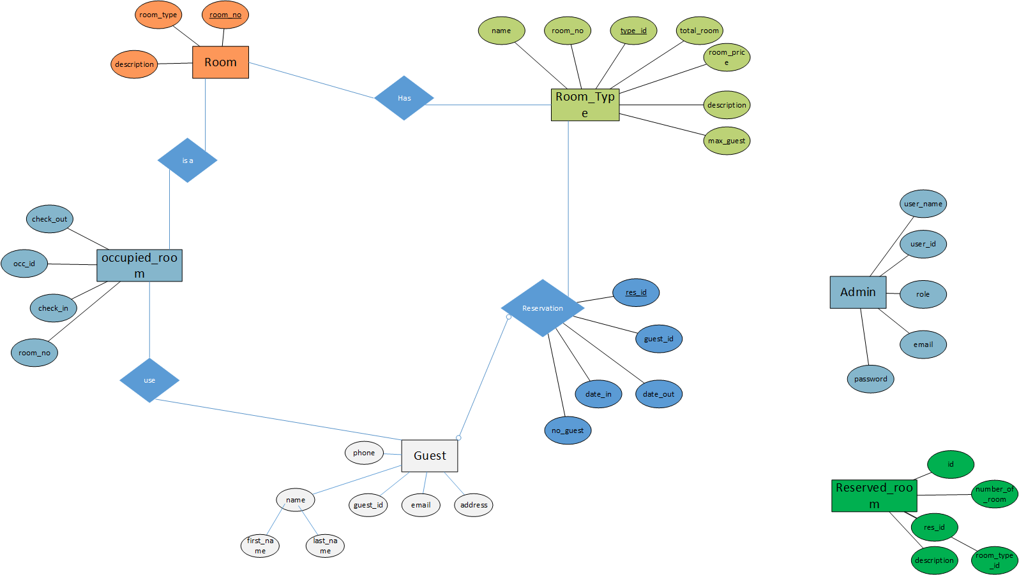

### Entity Detail

Reservation: thời điểm book phòng online

Occupied_room: thời điểm mà khách hang checkin

## Specific Requirements

### Business Rules

### Functional requirement specification

### Non-functional requirement specification

Availability

Supportability

Performance Requirements

User Interface

Design Constraints

Usability

Reliability

Scalability

Security